Vulnerability Assessment Report
Course: NIAI NAVTTC — Certified Ethical Hacker (CEH) Course
Assignment: Week 4 Lab Task
Prepared By: Talha Ali
Important Notice: All tasks documented in this report were performed only in an isolated virtual lab environment against an authorized target. No real networks or systems were targeted without explicit written permission.
1. Executive Summary
- Objective: Conduct a comprehensive vulnerability assessment across an organization's network infrastructure.
- Scope: Identify vulnerabilities in network devices, servers, and applications, and perform a risk analysis to prioritize and mitigate the identified vulnerabilities.
- Target: Metasploitable 2 (192.168.1.5)
- Goal: A complete vulnerability assessment report with a prioritized risk table showing vulnerabilities found, their severity scores, and recommended remediation steps.
2. Methodology & Scanner Selection
The following primary vulnerability scanner was utilized for this assessment:
- Option A: OpenVAS (Full Vulnerability Scanner)
- Option B: Nmap Vulnerability Scripts (Quick & Lightweight)
  - Setup/Execution: Nmap was executed directly from the Kali Linux command line targeting host 192.168.1.5.
  - Scan Types: Comprehensive vulnerability profiling was conducted utilizing the Nmap Scripting Engine (NSE). The specific commands executed were:
    - nmap --script=ftp-anon 192.168.1.5
    - nmap --script=vuln 192.168.1.5
    - nmap --script=http-vuln* 192.168.1.5

3. Web Application Vulnerabilities
Objective: Test the Metasploitable Web Server (accessible at http://192.168.1.5).
3.1. Automated Script Findings (Nmap NSE)
Rather than relying solely on manual testing, Nmap's vulnerability scripts (http-enum, http-sql-injection, http-csrf) were utilized to enumerate web application flaws based on the OWASP Top 10. Below are the findings extracted from the Nmap output:
- SQL Injection Vectors: The Nmap http-sql-injection script successfully identified dozens of potential SQL injection vulnerabilities. These were primarily located within the query parameters of the /mutillidae/ application (e.g., page=credits.php, page=user-info.php) and the /dav/ directory.
- Security Misconfigurations (Missing Cookie Flags): The scanner identified multiple administrative and Tomcat management interfaces (e.g., /admin/index.jsp, /admin/login.html) where the JSESSIONID cookie is issued without the HttpOnly flag. This makes the session cookies vulnerable to theft via Cross-Site Scripting (XSS).
- Directory Enumeration & Exposed Interfaces: The Nmap http-enum script successfully mapped out several sensitive, unauthenticated directories. These include potentially dangerous endpoints such as /phpMyAdmin/ (database management), /admin/ (potential administrative portal), and /manager/html (Apache Tomcat manager, which returned a 401 Unauthorized but confirmed its existence).
- Cross-Site Request Forgery (CSRF): The scanner flagged several forms that lack anti-CSRF tokens, most notably the login portals located at /dvwa/login.php and various /twiki/ documentation paths.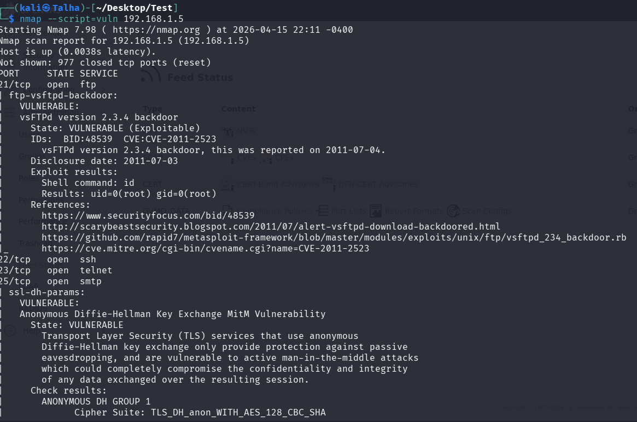

3.2. Nikto Web Server Scanner
Command used: nikto -h http://192.168.1.5
- Nikto Findings: The scanner flagged multiple critical misconfigurations. It identified that the server is running an obsolete version of Apache (2.2.8) which is vulnerable to numerous known exploits. It also detected that the X-Frame-Options header is missing (allowing Clickjacking), directory indexing is improperly enabled, and sensitive configuration files (like phpinfo.php) are publicly accessible, leaking backend system information.
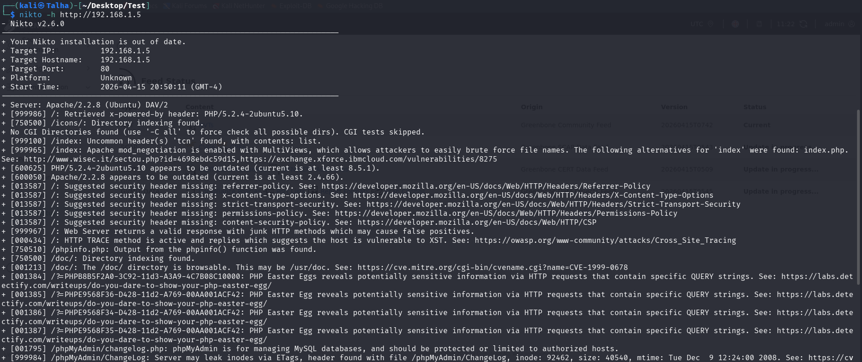

4. Risk Analysis & Prioritized Risk Table
This table organizes the Nmap vulnerability scan findings, prioritizing Critical and High severity issues first.
Vulnerability | Severity | CVSS | Recommended Fix
vsFTPd 2.3.4 Backdoor (Port 21) | Critical | 9.8 | The FTP service contains a known backdoor (CVE-2011-2523) allowing root shell access. Upgrade vsFTPd or disable the service immediately.
UnrealIRCd Backdoor (Port 6667) | Critical | 9.8 | Nmap flagged this as a trojaned version of UnrealIRCd. Remove the service and install a clean, verified build.
Java RMI Registry RCE (Port 1099) | Critical | 9.8 | Default configuration allows loading classes from remote URLs, leading to remote code execution. Update configurations and restrict network access.
FTP allows anonymous login (Port 21) | High | 7.5 | Check confirmed by ftp-anon script. Modify the FTP configuration to disable anonymous logins.
SSL/TLS POODLE & Logjam MitM (Ports 25/5432) | High | 7.4 | Vulnerable to CVE-2014-3566 (POODLE) and CVE-2015-4000 (Logjam). Disable SSLv3, enforce modern TLS (1.2/1.3), and use strong Diffie-Hellman groups.
SQL Injection & CSRF (Port 80) | High | 7.3 | The /mutillidae and /dav directories contain numerous SQLi vectors. Implement prepared statements and anti-CSRF tokens in the web applications.
Exposed Admin Interfaces (Port 8180) | Medium | 5.3 | Nmap identified /admin and /manager/html folders with missing httponly cookie flags. Restrict access to these directories via IP whitelisting and enforce secure cookies.

Final Step: Report Conclusion
All that is left is to finish Section 5! Here is a conclusion based on your Nmap findings that you can drop in to complete the document.
5. Conclusion
- Summary of Network Posture: The target system (192.168.1.5) is extremely vulnerable and insecure by design. Nmap scanning revealed multiple critical backdoors granting remote root access (vsFTPd and UnrealIRCd), a misconfigured Java RMI registry allowing remote code execution, and widespread web application flaws including SQL Injection and exposed administrative directories. The cryptographic posture is also weak, relying on outdated SSL/TLS implementations vulnerable to Man-in-the-Middle attacks.
- Next Steps: The most urgent priority is closing the critical backdoors on ports 21 and 6667 to prevent immediate system compromise. Following that, anonymous FTP access must be revoked, web applications must be sanitized against injection attacks, and all SSL/TLS configurations must be updated to modern standards to protect data in transit.

